Bài 4. Activity và intent

Giao diện của main activity:

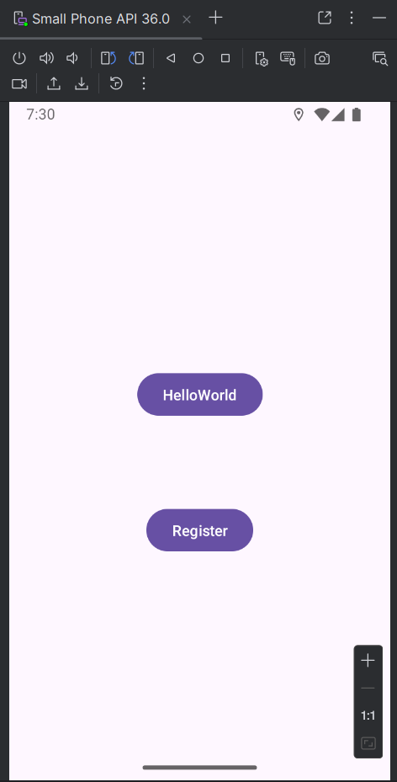

**- activity_main.xml**

<?xml version="1.0" encoding="utf-8"?>  
<androidx.constraintlayout.widget.ConstraintLayout xmlns:android="http://schemas.android.com/apk/res/android"  
 xmlns:app="http://schemas.android.com/apk/res-auto"  
 xmlns:tools="http://schemas.android.com/tools"  
 android:id="@+id/main"  
 android:layout_width="match_parent"  
 android:layout_height="match_parent"  
 tools:context=".MainActivity">  
  
 <Button  
 android:id="@+id/btnHelloWorld"  
 android:layout_width="wrap_content"  
 android:layout_height="wrap_content"  
 android:layout_marginTop="228dp"  
 android:onClick="onBtnHelloClick"  
 android:text="HelloWorld"  
 app:layout_constraintEnd_toEndOf="parent"  
 app:layout_constraintStart_toStartOf="parent"  
 app:layout_constraintTop_toTopOf="parent"  
 tools:ignore="HardcodedText,OnClick" />  
  
 <Button  
 android:id="@+id/btnRegister"  
 android:layout_width="wrap_content"  
 android:layout_height="wrap_content"  
 android:layout_marginTop="80dp"  
 android:onClick="onBtnRegisterClick"  
 android:text="Register"  
 app:layout_constraintEnd_toEndOf="parent"  
 app:layout_constraintStart_toStartOf="parent"  
 app:layout_constraintTop_toBottomOf="@id/btnHelloWorld"  
 tools:ignore="HardcodedText,OnClick" />  
  
  
</androidx.constraintlayout.widget.ConstraintLayout>

**Broadcast Receiver**

1. Bài 1: Đăng ký BroadcastReceiver bằng code. Tạo ứng dụng nhận tin nhắn

Ảnh có chứa văn bản, ảnh chụp màn hình, đa phương tiện, phần mềm

Nội dung do AI tạo ra có thể không chính xác.Ảnh có chứa văn bản, đồ điện tử, ảnh chụp màn hình, đa phương tiện

Nội dung do AI tạo ra có thể không chính xác.

**MainActivity.java**

package com.example.teoapp;  
  
import android.Manifest;  
import android.content.BroadcastReceiver;  
import android.content.Context;  
import android.content.Intent;  
import android.content.IntentFilter;  
import android.content.pm.PackageManager;  
import android.os.Build;  
import android.os.Bundle;  
import android.os.Bundle;  
import android.telephony.SmsMessage;  
import android.widget.TextView;  
import android.widget.Toast;  
  
import androidx.annotation.NonNull;  
import androidx.appcompat.app.AppCompatActivity;  
import androidx.core.app.ActivityCompat;  
import androidx.core.content.ContextCompat;  
  
import com.example.teoapp.R;  
  
public class MainActivity extends AppCompatActivity {  
  
 private static final int *REQ_SMS* = 1001;  
  
 private BroadcastReceiver broadcastReceiver;  
 private IntentFilter filter;  
 private TextView tvContent;  
  
 @Override  
 protected void onCreate(Bundle savedInstanceState) {  
 super.onCreate(savedInstanceState);  
 setContentView(R.layout.*activity_main*);  
  
 tvContent = findViewById(R.id.*tv_content*);  
  
 // xin quyền RECEIVE_SMS lúc runtime  
 ensureReceiveSmsPermission();  
  
 // khởi tạo BroadcastReceiver  
 initBroadcastReceiver();  
 }  
  
 */**  
 * Hàm xin quyền RECEIVE_SMS nếu chưa có  
 */* private void ensureReceiveSmsPermission() {  
 if (ContextCompat.*checkSelfPermission*(this, Manifest.permission.*RECEIVE_SMS*)  
 != PackageManager.*PERMISSION_GRANTED*) {  
 ActivityCompat.*requestPermissions*(this,  
 new String[]{Manifest.permission.*RECEIVE_SMS*}, *REQ_SMS*);  
 }  
 }  
  
 */**  
 * Tạo BroadcastReceiver để lắng nghe SMS đến  
 */* private void initBroadcastReceiver() {  
 filter = new IntentFilter("android.provider.Telephony.SMS_RECEIVED");  
  
 broadcastReceiver = new BroadcastReceiver() {  
 @Override  
 public void onReceive(Context context, Intent intent) {  
 Toast.*makeText*(context, getString(R.string.*you_have_a_new_message*),  
 Toast.*LENGTH_LONG*).show();  
  
 Bundle bundle = intent.getExtras();  
 if (bundle == null) return;  
 Object[] pdus = (Object[]) bundle.get("pdus");  
 if (pdus == null) return;  
  
 StringBuilder sms = new StringBuilder();  
 for (Object pdu : pdus) {  
 SmsMessage msg;  
 if (Build.VERSION.*SDK_INT* >= Build.VERSION_CODES.*M*) {  
 String format = bundle.getString("format");  
 msg = SmsMessage.*createFromPdu*((byte[]) pdu, format);  
 } else {  
 msg = SmsMessage.*createFromPdu*((byte[]) pdu);  
 }  
  
 sms.append("From: ")  
 .append(msg.getOriginatingAddress())  
 .append("\n")  
 .append(msg.getMessageBody())  
 .append("\n\n");  
 }  
 tvContent.setText(sms.toString());  
 }  
 };  
 }  
  
 */**  
 * Đăng ký Receiver khi Activity hiển thị  
 */* @Override  
 protected void onResume() {  
 super.onResume();  
 if (broadcastReceiver == null) initBroadcastReceiver();  
 registerReceiver(broadcastReceiver, filter);  
 }  
  
 */**  
 * Hủy đăng ký khi Activity bị ẩn  
 */* @Override  
 protected void onStop() {  
 super.onStop();  
 if (broadcastReceiver != null) {  
 unregisterReceiver(broadcastReceiver);  
 }  
 }  
  
 */**  
 * Kết quả xin quyền  
 */* @Override  
 public void onRequestPermissionsResult(int requestCode,  
 @NonNull String[] permissions,  
 @NonNull int[] grantResults) {  
 super.onRequestPermissionsResult(requestCode, permissions, grantResults);  
 if (requestCode == *REQ_SMS*) {  
 if (grantResults.length > 0 && grantResults[0] == PackageManager.*PERMISSION_GRANTED*) {  
 Toast.*makeText*(this, "Permission RECEIVE_SMS granted", Toast.*LENGTH_SHORT*).show();  
 } else {  
 Toast.*makeText*(this, "Permission RECEIVE_SMS denied", Toast.*LENGTH_SHORT*).show();  
 }  
 }  
 }  
}

**activity_main.xml**

<LinearLayout xmlns:android="http://schemas.android.com/apk/res/android"  
 xmlns:tools="http://schemas.android.com/tools"  
 android:layout_width="match_parent"  
 android:layout_height="match_parent"  
 android:orientation="vertical"  
 android:padding="@dimen/margin_base"  
 tools:context=".MainActivity">  
  
 <TextView  
 android:layout_width="match_parent"  
 android:layout_height="184dp"  
 android:text="@string/you_have_a_new_message"  
 android:textSize="@dimen/text_medium" />  
  
 <TextView  
 android:id="@+id/tv_content"  
 android:layout_width="match_parent"  
 android:layout_height="wrap_content"  
 android:textSize="@dimen/text_medium" />  
</LinearLayout>

**Bài 2: Sử dụng BroadcastReceiver đăng ký trong AndroidManifest để tạo**

**ứng dụng nhận biết trạng thái sạc pin/ không sạc pin.**

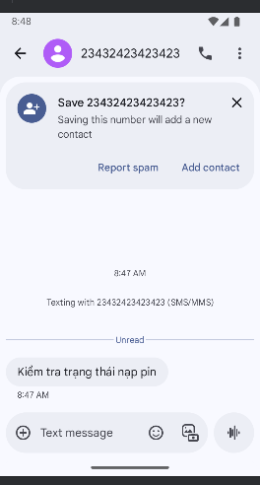

**PowerStateChangeReceiver.java**

package com.example.teoapp;  
  
import android.content.BroadcastReceiver;  
import android.content.Context;  
import android.content.Intent;  
import android.widget.Toast;  
  
public class PowerStateChangeReceiver extends BroadcastReceiver {  
 @Override  
 public void onReceive(Context context, Intent intent) {  
 if (intent == null || intent.getAction() == null) return;  
  
 String action = intent.getAction();  
 if (Intent.*ACTION_POWER_CONNECTED*.equals(action)) {  
 Toast.*makeText*(context, R.string.*power_connected*, Toast.*LENGTH_LONG*).show();  
 } else if (Intent.*ACTION_POWER_DISCONNECTED*.equals(action)) {  
 Toast.*makeText*(context, R.string.*power_disconnected*, Toast.*LENGTH_LONG*).show();  
 }  
 }  
}

**activity_main.xml**

<LinearLayout xmlns:android="http://schemas.android.com/apk/res/android"  
 xmlns:tools="http://schemas.android.com/tools"  
 android:layout_width="match_parent"  
 android:layout_height="match_parent"  
 android:orientation="vertical"  
 android:padding="@dimen/margin_base"  
 tools:context=".MainActivity">  
  
 <TextView  
 android:layout_width="wrap_content"  
 android:layout_height="wrap_content"  
 android:text="Power State Receiver"  
 android:textSize="20sp"  
 tools:ignore="HardcodedText" />  
</LinearLayout>

**Bài 4: Dùng broadcastReceiver để tạo app trả lời tin nhắn trong trường hợp**

**khẩn cấp**